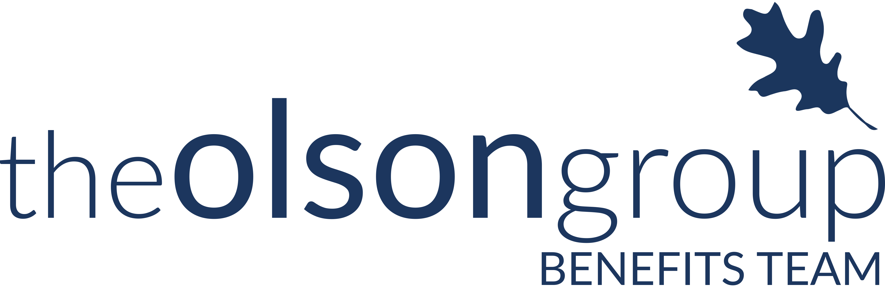

2016-2017 COBRA Compliance Calendar

Meet Sally. Sally is a strong, independent business person, who don’t need no man. But she does have one, because she chose to. Sally and her husband, Steve, are now expecting their first child…

Here is a timeline of Sally and ABC Inc.’s venture through the workings of the Family Medical Leave Act (FMLA).

November 2016

Sunday | Monday | Tuesday | Wednesday | Thursday | Friday | Saturday
 |  | 1 | 2 | 3 | 4 | 5
6 | 7 | 8 | 9 | 10 | 11 | 12
13 | 14 | 15 | 16 | 17 | 18 | 19
20 | 21 | 22 | 23 | 24 | 25 | 26
27 | 28 | 29 | 30
Nov. 1 | ABC Inc. calculates its number of employees
 | ABC Inc. determines that during the current or preceding year it employed 55 full-time employees in 20 or more workweeks, making it a FMLA-applicable employer.
Nov. 2 | Check of General Notice
 | ABC Inc. checks to ensure that it has posted the proper notice of employees’ FMLA rights (WH 1420) in a conspicuous place where employees and applicants for employment can see it.
December 2016
No significant dates.
January 2017

\
Sunday | Monday | Tuesday | Wednesday | Thursday | Friday | Saturday
1 | 2 | 3 | 4 | 5 | 6 | 7
8 | 9 | 10 | 11 | 12 | 13 | 14
15 | 16 | 17 | 18 | 19 | 20 | 21
22 | 23 | 24 | 25 | 26 | 27 | 28
29 | 30 | 31

Jan. 1 | Sally Requests FMLA Leave (at least 30 days in advance)
 | Sally provides ABC Inc. with a notice that she is requesting time off through FMLA, for the birth of her child. The leave will begin on February 1, 2017.
Jan. 5 | Eligibility Notice (within 5 days of FMLA request)  ABC Inc. provides Sally with a notice that she is eligible for FMLA leave. Sally has worked at ABC Inc. for at least 12 months, and worked over 1,250 hours within the 12 months prior to February 1, 2017 (the start of Sally’s FMLA leave).
Jan. 11 | Designation Notice (within 5 business days of determining that leave qualifies as FMLA)  ABC Inc. provides Sally with a notice that her leave qualifies as FMLA, because it is for the birth of her child.

February 2017

Sunday | Monday | Tuesday | Wednesday | Thursday | Friday | Saturday
 |  |  | 1 | 2 | 3 | 4
5 | 6 | 7 | 8 | 9 | 10 | 11
12 | 13 | 14 | 15 | 16 | 17 | 18
19 | 20 | 21 | 22 | 23 | 24 | 25
26 | 27 | 28

Feb. 1 | Sally begins her FMLA leave
 | Sally begins her 12-week FMLA leave.
Feb. 1 | Maintenance of health benefits
 | ABC Inc. is required to maintain group health coverage for Sally throughout her FMLA leave.

March 2017

Sunday | Monday | Tuesday | Wednesday | Thursday | Friday | Saturday
 |  |  | 1 | 2 | 3 | 4
5 | 6 | 7 | 8 | 9 | 10 | 11
12 | 13 | 14 | 15 | 16 | 17 | 18
19 | 20 | 21 | 22 | 23 | 24 | 25
26 | 27 | 28 | 29 | 30 | 31

Mar. 30 | General Notice of COBRA Rights (Within 90 days after the date group health coverage begins)
 | ABC Inc. provides Sally, and all employees and their spouses, who are covered under the company’s group healthcare plan, with a notice of the rights they have under COBRA.

April 2017

Sunday | Monday | Tuesday | Wednesday | Thursday | Friday | Saturday
 |  |  |  |  |  | 1
2 | 3 | 4 | 5 | 6 | 7 | 8
9 | 10 | 11 | 12 | 13 | 14 | 15
16 | 17 | 18 | 19 | 20 | 21 | 22
23 | 24 | 25 | 26 | 27 | 28 | 29
30 | 31

Apr. 30 | Job Restoration
 | Upon Sally’s return she is restored with her original job. ABC Inc. enforces no pay reduction, nor any other adverse employment action against Sally, for using FMLA leave.

This is just an example; dates are subject to change based on actual events. This is not a full-list of an employer’s duties under FMLA. For a complete checklist visit:
http://compliance.theolsongroup.com/
