FMLA Compliance Checklist for 2017

This checklist is intended to aid employers in reviewing their company’s compliance with key regulations of the Family Medical Leave Act. If you have further questions, talk to an associate at The Olson Group for a full Compliance Assessment.

For more information, visit https://theolsongroup.com or call 402-289-1046.

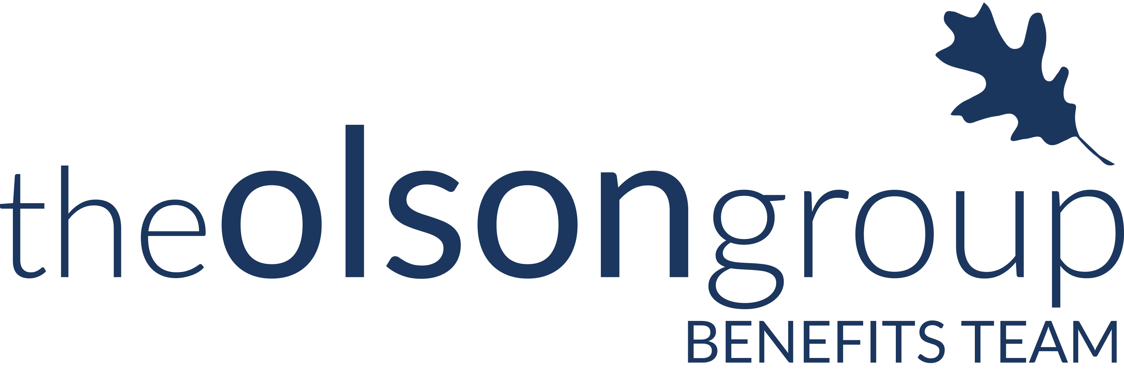
Checklist | Regulation | To Do List | Relevant For: | Due Date:
 | Calculate Number of Employees | - Determine if your company employed 50 or more employees (within 75 miles) in 20 or more workweeks in the current or proceeding year  - Know that this includes joint employers and successors of covered employers | Every employer | Annually
 | Eligibility Notice | - Provide an employee requesting FMLA with a notice of their eligibility that details expectations and obligations of the employee, and consequences of failure to meet these obligations  - Understand that to be eligible for FMLA, employees must:  - Have worked for that employer for at least 12 months  - Have worked at least 1,250 hours over those 12 months prior to the start of FMLA  - Work for a location where at least 50 employees are employed within 75 miles | Every FMLA-applicable employer | Within 5 business days of FMLA-leave request
 | Maintenance of Health Benefits | - Maintain group health insurance coverage, including family coverage for any employee on FMLA leave  - The terms and conditions of coverage have to be the same as if the employee had not taken leave  - Know that certain other benefits must also be maintained | Every FMLA-applicable employer | Upon an employee’s use of FMLA
 | Job Restoration | - Restore an employee’s original job or an “equivalent” job, upon their return  - Know that an equivalent job means a position that is virtually identical to the original job in terms of pay, benefits, and other employment terms and conditions | Every FMLA-applicable employer | Upon an employee’s return from FMLA
 | General Notice  (WH Publication 1420) | - Post WH Publication 1420 (approved by the Secretary of Labor), which explains rights and responsibilities under FMLA  - Know that every employer FMLA-applicable employer has to post a general notice, even if they have no eligible employees  - Understand that the penalty for violations has increased to $166 for each offense | Every FMLA-applicable employer | Must be posted prominently where it can by readily seen (Even if you have no FMLA-eligible employees).
 | Designation Notice | - Provide an employee requesting FMLA, with a notice that his or her leave qualifies as FMLA  - Know that leave counts as FMLA if it is:  - For the birth of a child, and to care for that newborn  - For the placement with the employee of a child for adoption or foster care  - Due to a serious health condition  - To care for an immediate family member (spouse, child, or parent) with a serious health condition | Every FMLA-applicable employer | Within 5 business days of determining that leave qualifies as FMLA
Checklist | Regulation | To Do List | Relevant For: | Due Date:
 | General Notice | - Provide employees with a summary of the major provisions of the FMLA, that also describes how to file a complaint  - Know that you must include the general notice in employee handbooks or other written guidance to employees concerning benefits  - Or, must distribute a copy of the notice to each new employee upon hiring | Every FMLA-applicable employer | Must be provided to each eligible employee upon hiring.

Prepare yourself and your company for these compliance requirements to change or be altered. Stay up-to-date on the latest information regarding FMLA compliance by visiting http://compliance.theolsongroup.com/.

