FLSA Compliance Checklist for 2017

This checklist is intended to aid employers, to review their company’s compliance with key regulations of the Fair Labor Standards Act. If you have further questions, talk to an associate at The Olson Group for a full Compliance Assessment.

For more information, visit https://theolsongroup.com or call 402-289-1046.

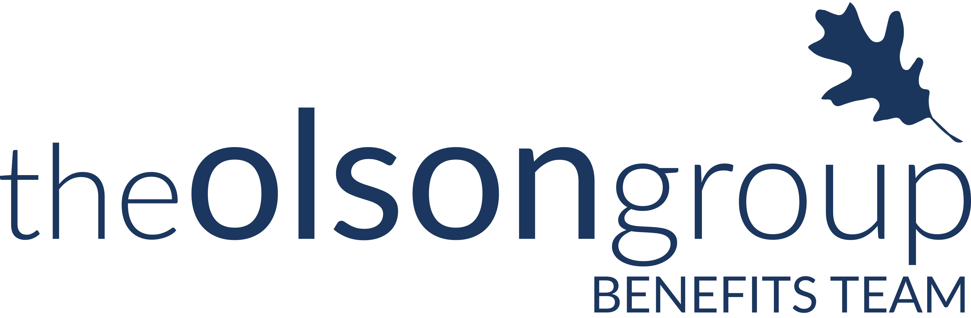
Checklist | Regulation | To Do List | Relevant For: | Due Date:
 | Review Applicability | - Determine if the FLSA applies to your business  - Know that a covered enterprise is one:  - Whose annual gross volume of sales made or business done is not less than $500,000; or  - Is engaged in the operation of a hospital, an institution primarily engaged in the care of the sick, the aged, or the mentally ill who reside on the premises; a school for mentally or physically disabled or gifted children; a preschool, an elementary or secondary school, or an institution of higher education; or  - Is an activity of public agency | Every employer | Annually
 | Required Minimum Wage | - Ensure all employees are being paid at least the required minimum wage  - Know that the current federal FLSA rate is $7.25 per hours, but his varies by State and City (For example, the minimum wage in Nebraska is $9 per hour).  - Review deductions to employee payments, repayments, or work-related purchases to ensure they don’t cut employees’ pay to below the required minimum wage | Every FLSA-applicable employee | Every pay period
 | Required Overtime Pay | - Ensure that all nonexempt employees are being paid at time and a half for any amount of time worked over 40 hours in a single workweek  - Be certain that deductions or employee payments, repayments, or work-related purchases are not improperly cutting into overtime pay  - Make sure all overtime hours are properly recorded, identified, and paid (including those done at a different location or in a different role) | Every FLSA-applicable employee | Every pay period
 | Employee Classification | - Ensure that all employees who are categorized as “exempt” meet the proper requirements  - Know that requirements for exemption are:  - The employee must make at least $455 a week or $23,660 annually; and  - Perform executive, administrative, professional, computer-based, or outside sales duties (These duties have to be examined on an employee-by-employee basis; exemption decisions cannot be based on job titles or descriptions)  - Understand that the salary threshold could increase in the future  - The proposed new threshold would be $913 a week or $47,476 annually | Every FLSA-applicable employee | New threshold has been placed on hold
Checklist | Regulation | To Do List | Relevant For: | Due Date:
 | Child-Labor Provisions | - Understand the child-labor restrictions protected under the FLSA:  - There is an age-16 limit for general occupations  - There is an age-18 limit for occupations the U.S. Secretary of Labor deems “hazardous”  - 14 and 15 year olds may be employed, but only within strict hours and times of day limits | Every FLSA-applicable employee | ASAP
 | Posters Displayed | - Ensure that the proper FLSA-related posters (as approved by the DOL) are displayed throughout your workplace and visible to employees and applicants | Every FLSA-applicable employee | ASAP
 | State and Local Wage-Hour Requirements | - Understand that FLSA does not trump and state or local wage-hour provisions (such as a high min. wage, daily overtime, etc.) that are more strict  - Know all state and local requirements for areas your business operates in | Every FLSA-applicable employee | ASAP

Prepare yourself and your company for these compliance requirements to change or be altered. Stay up-to-date on the latest information regarding FLSA compliance by visiting http://compliance.theolsongroup.com/.

